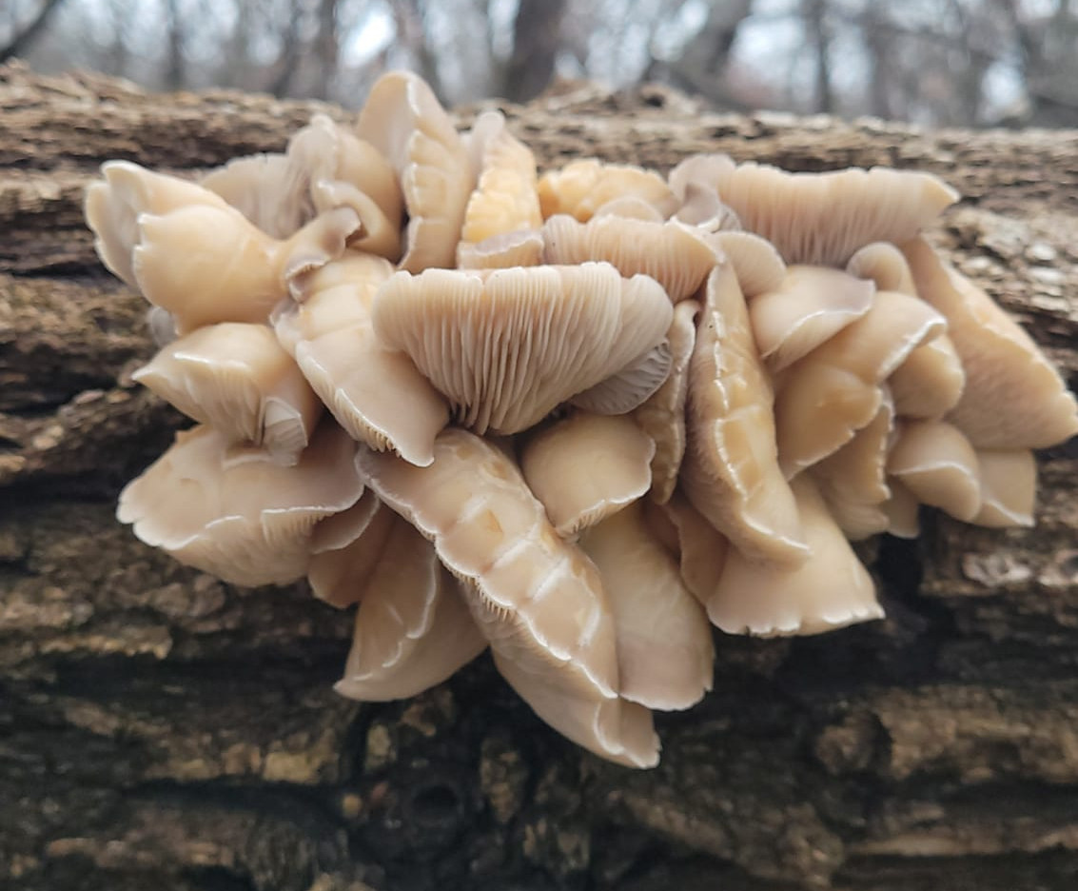

Look for oyster mushrooms growing from wood.

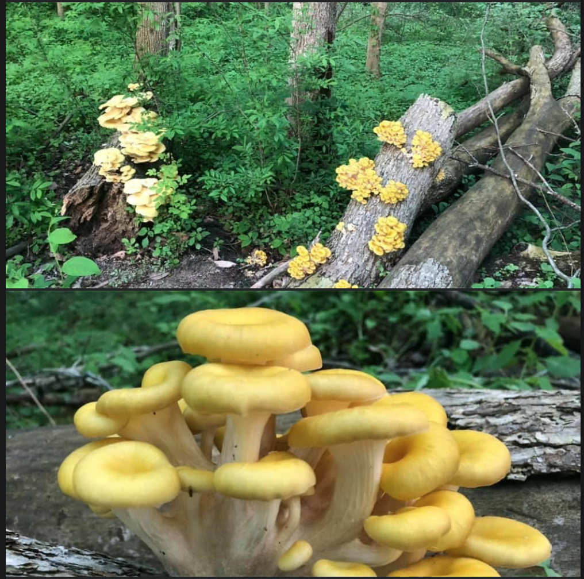

These are golden oysters. Keep looking for oysters.



I don’t know what to look for in March :(



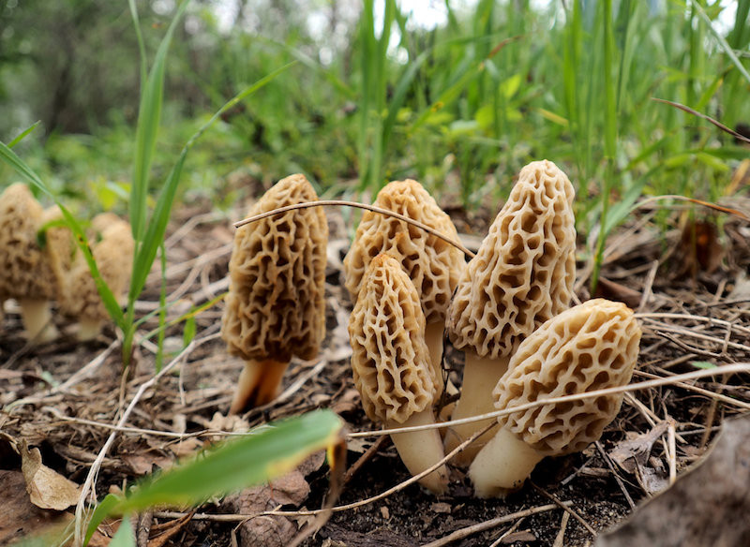

Look for the coveted Morels in April under elms or fruit trees. Beware the poisonous false morel look-alike!



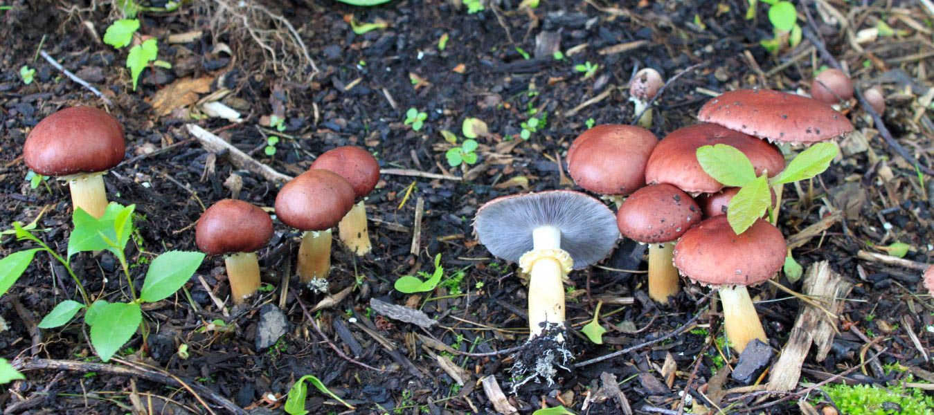

Look for wine caps in May in mulch.



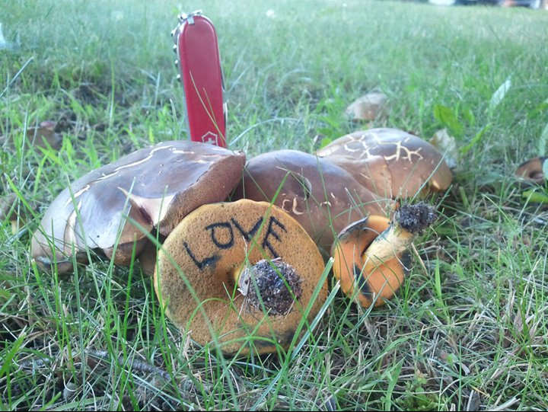

Look for Boletes, aka Porcini or Cepes, in June near big old trees.



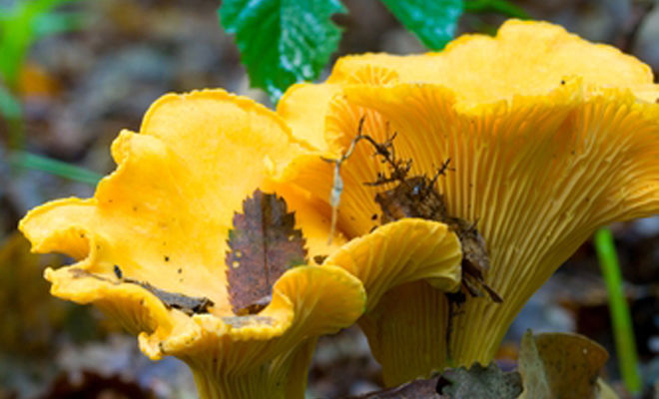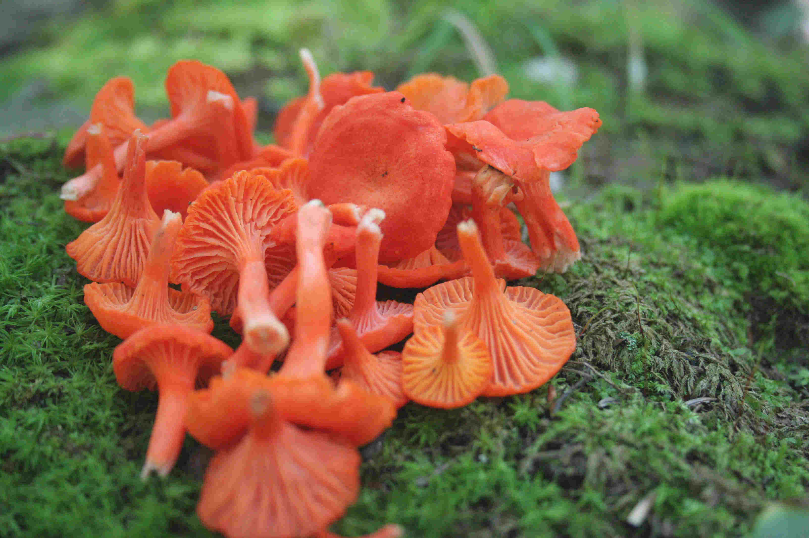

Look for Chanterelles in June. They have ridges, not gills. At left are golden chants; right, the much-sought-after cinnabar chant.



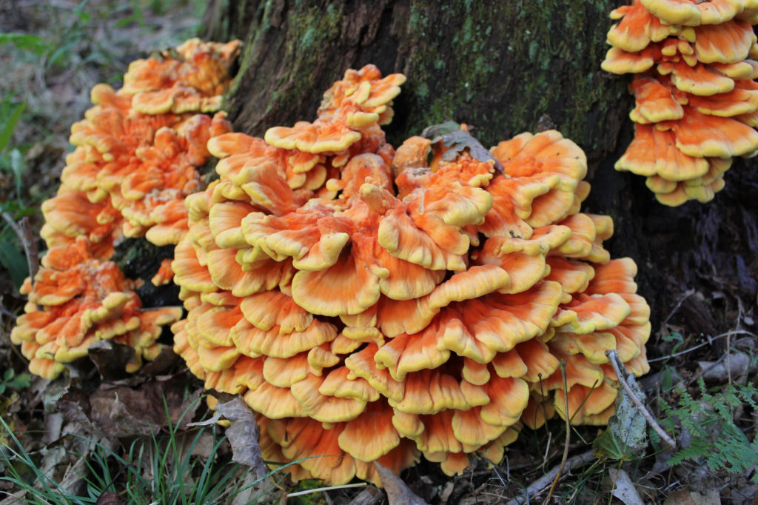

Look for Chicken of the Woods in August at the base of trees like oak



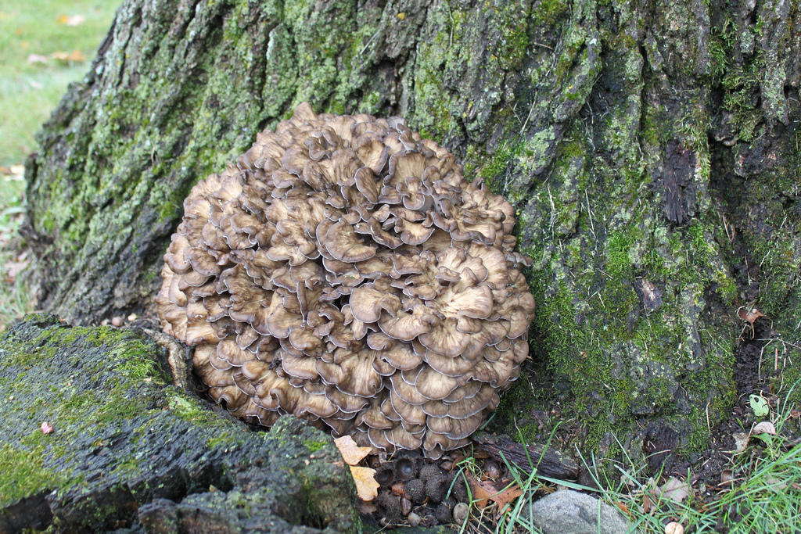

Look carefully for Hen of the woods at the base of trees like oak. They can sometimes hide in leaf litter!



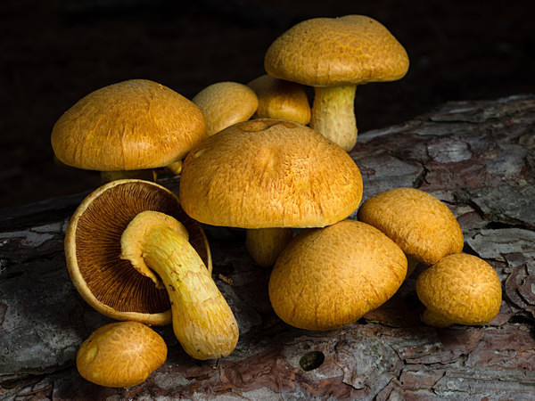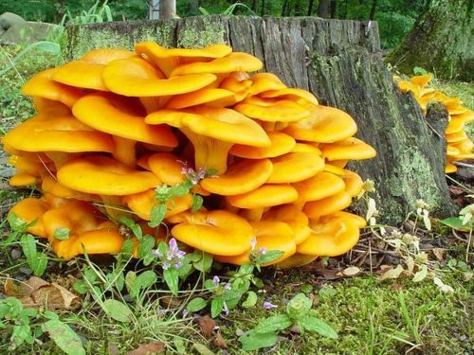

Look for the beautiful Gymnopilus (Left) and their look-alike the Jack O’ Lantern (Right) in October. Don’t eat either--they are poisonous! Gyms contain psilocybin, and Jacks will make you sick!

